**15.**

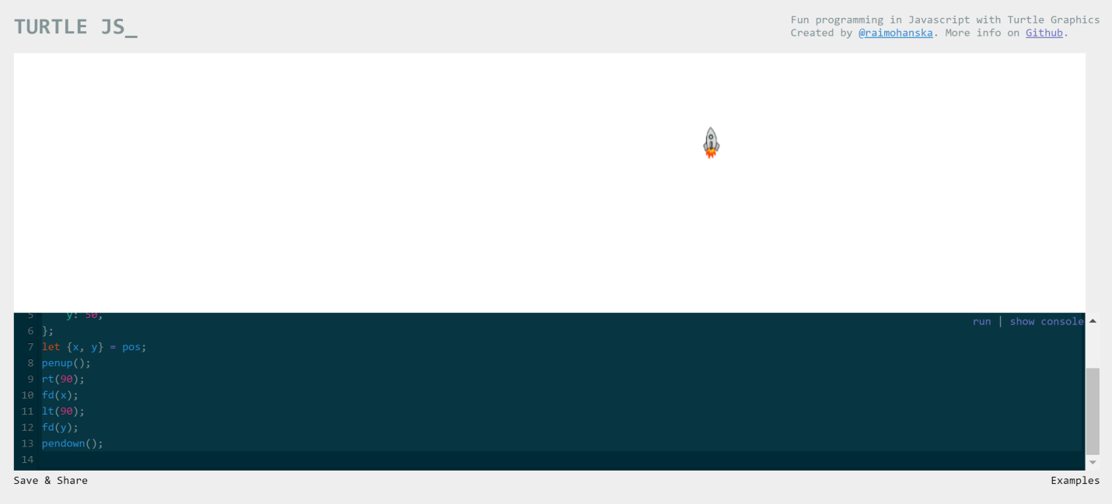

clear();

setshape('rocket');

const pos = {

x: 200,

y: 50,

};

let {x, y} = pos;

penup();

rt(90);

fd(x);

lt(90);

fd(y);

pendown();

**16.**

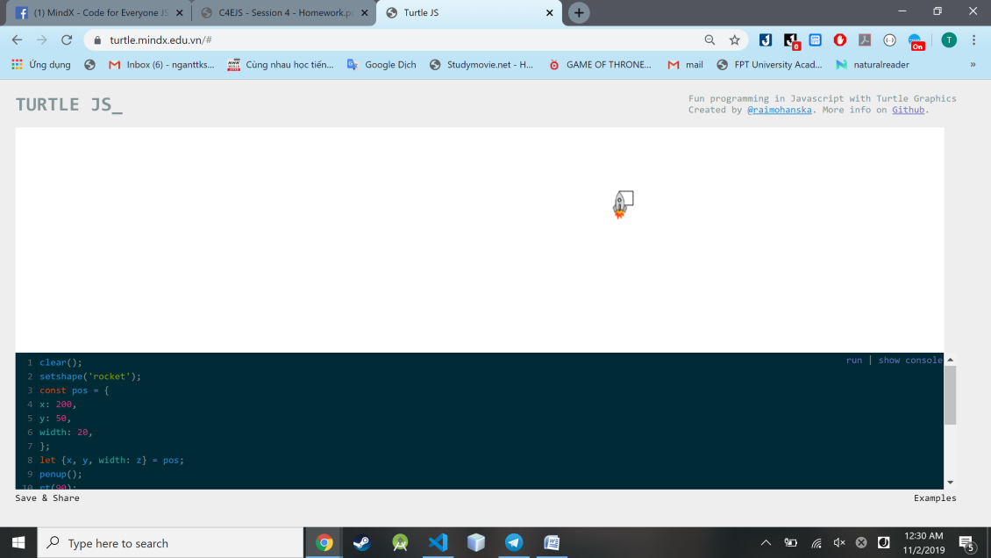

clear();

setshape('rocket');

const pos = {

x: 200,

y: 50,

width: 20,

};

let {x, y, width: z} = pos;

penup();

rt(90);

fd(x);

lt(90);

fd(y);

pendown();

for(let i = 0; i < 4; i++) {

fd(z);

rt(90);

}

17.

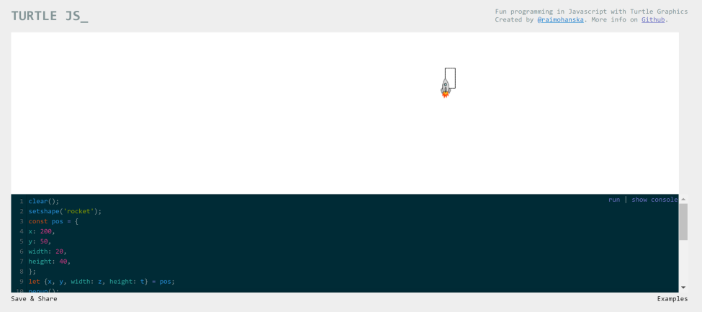

clear();

setshape('rocket');

const pos = {

x: 200,

y: 50,

width: 20,

height: 40,

};

let {x, y, width: z, height: t} = pos;

penup();

rt(90);

fd(x);

lt(90);

fd(y);

pendown();

for(let i = 0; i < 2; i++) {

fd(t);

rt(90);

fd(z);

rt(90);

}

18.

